A

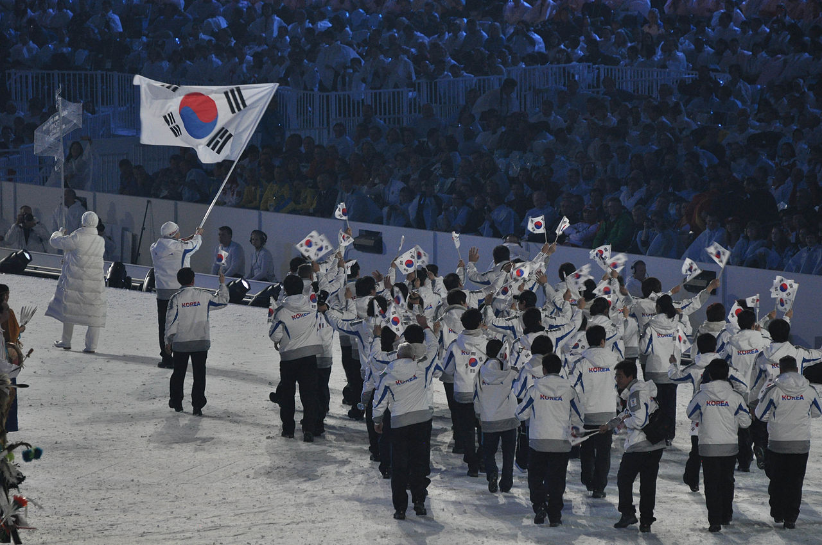

[This Photo](https://www.foreignbrief.com/asia-pacific/warming-ice-north-korea-winter-olympics/attachment/1280px-korea_olympic_march_2010/) by Unknown Author is licensed under [CC BY-NC](https://creativecommons.org/licenses/by-nc/3.0/)

B

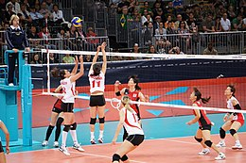

[This Photo](https://en.wikipedia.org/wiki/Volleyball) by Unknown Author is licensed under [CC BY-SA](https://creativecommons.org/licenses/by-sa/3.0/)

A B

A B A